WATER JUG PYHHON CODE
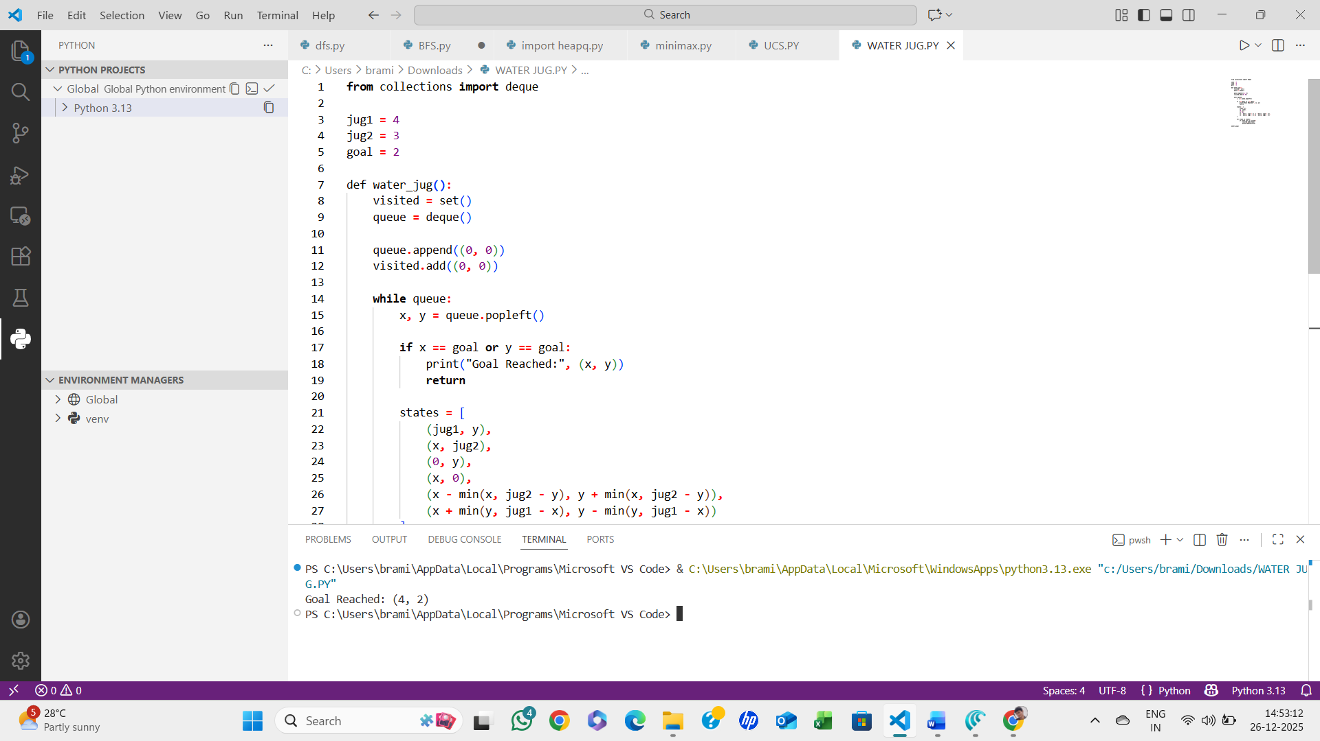
ALGORITHM:
- Start with initial state (0, 0)
- Use a queue for BFS
- Generate all possible next states
- Avoid revisiting states
- Stop when goal state is reached
- Print the path
- STOP

